1.Simple for loop output

#!/bin/bash

for i in 1 2 3 4 5
do
echo "Welcome $i times"
done

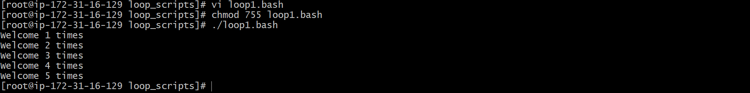

2.Simple for loop output

#!/bin/bash

for i in eat run jump play
do
echo See Imran $i
done

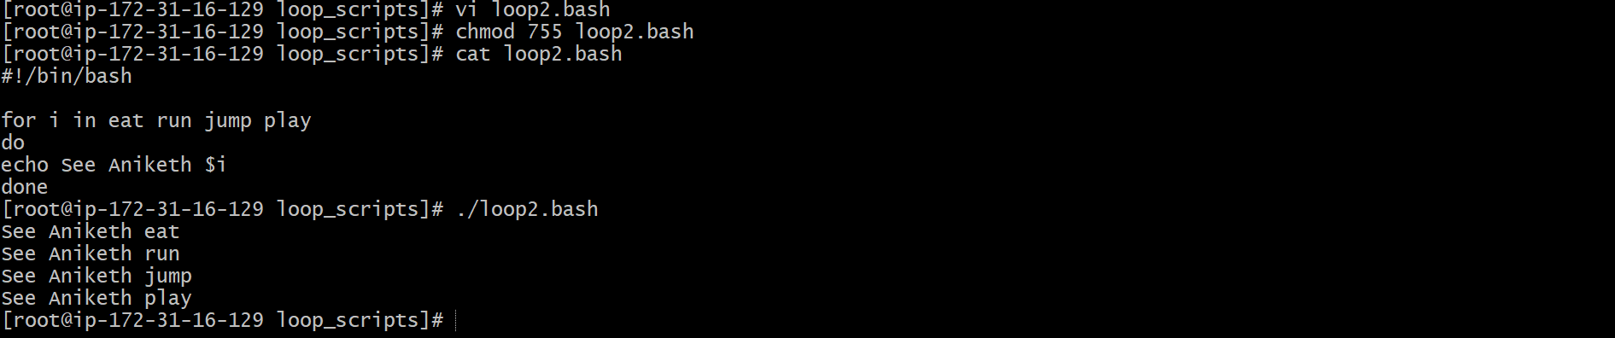

3.for loop to create 5 files named 1-5

#!/bin/bash

for i in {1..5}
do
touch $i
done

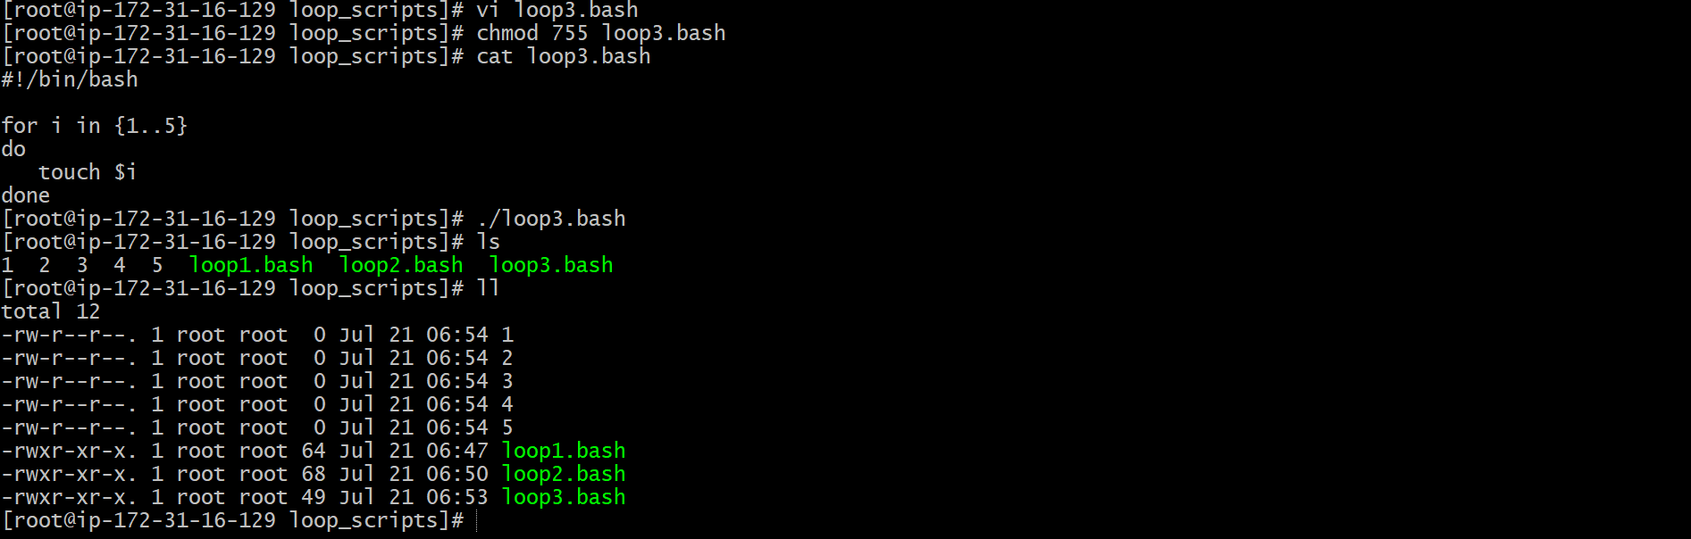

4.for loop to delete 5 files named 1-5

#!/bin/bash

for i in {1..5}
do
rm $i
done

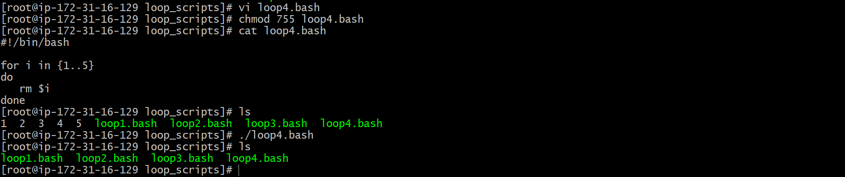

5.Specify days in for loop

#!/bin/bash

i=1
for day in Mon Tue Wed Thu Fri
do
echo "Weekday $((i++)) : $day"
done

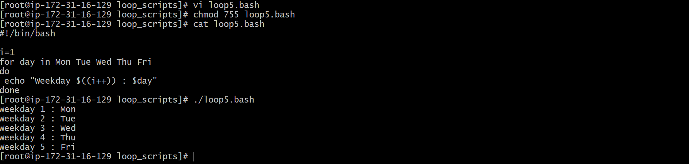

6.List all users one by one from /etc/passwd file

#!/bin/bash

i=1
for username in `awk -F: '{print $1}' /etc/passwd`
do
echo "Username $((i++)) : $username"
done

